The University of Azad Jammu and Kashmir, Muzaffarabad


Course: Computer Network
Course Code: CS-2203
Roll No: 2024-SE-13
Lab: 6
Submitted To: Engr. Asma Javaid
Submitted By: Sughra Mumshad
Date: 1 May, 2026

Department Of Software Engineering

Open Router in Cisco Packet Tracer:

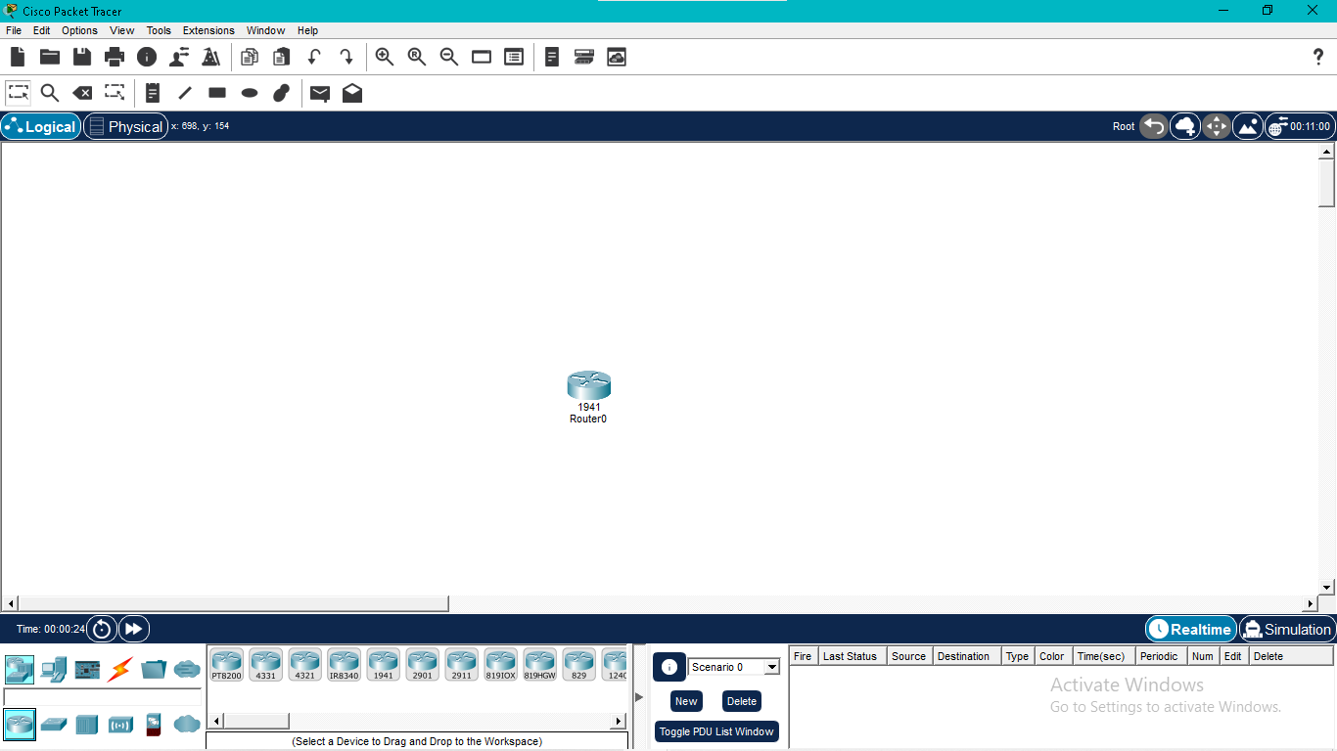
Router CLI opening (User EXEC Mode):
“This shows the router CLI in User EXEC mode where basic monitoring commands can be executed.”

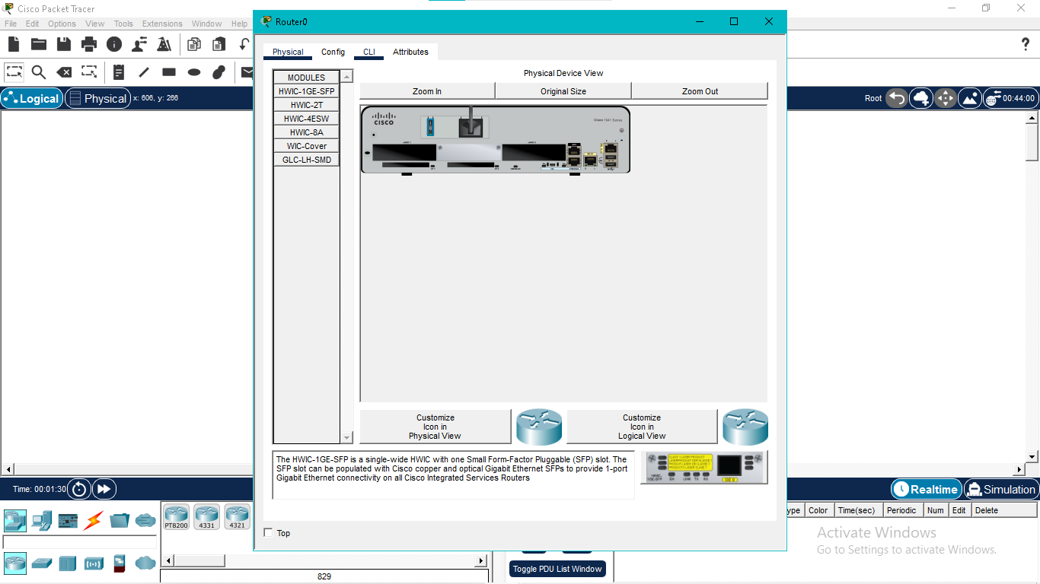

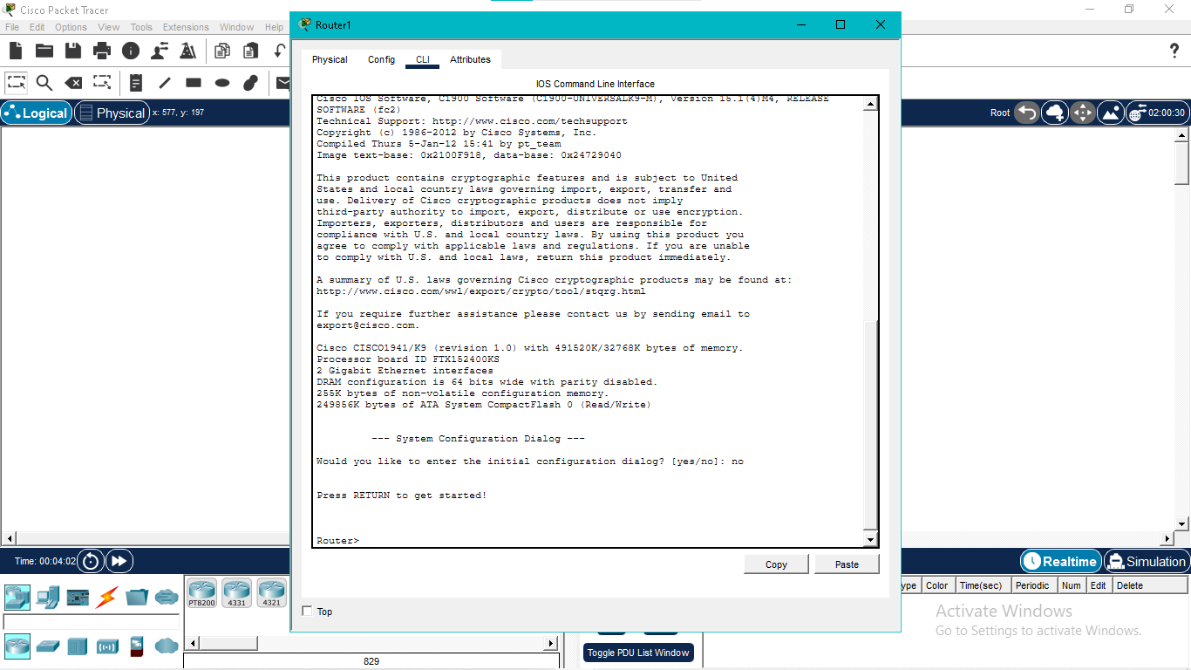
Enter Privileged EXEC Mode:
“Using the enable command, the router enters Privileged EXEC mode which provides advanced access.”

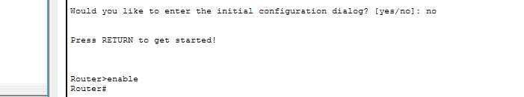
Enter Global Configuration Mode:
“This command opens Global Configuration mode where router settings can be changed.”
Set Enable Password:

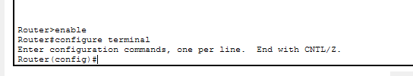

Encrypt Passwords:
“This command encrypts all plain text passwords in the configuration for security.”

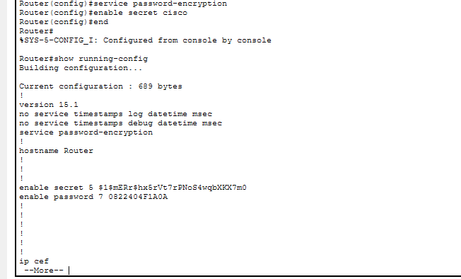
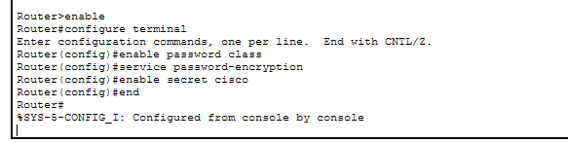

Save Configuration to Startup Config:
“This command saves the current configuration from RAM to NVRAM so it is not lost after restart.”
